Algebra II Graphing rational functions. Name:__________________________________________
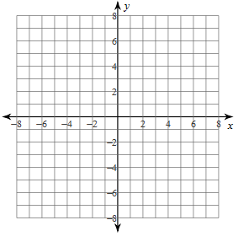
1. Identify the holes, vertical asymptotes, x-intercepts, horizontal asymptotes, and domain and range of each. Then sketch the graph.
$$y=\frac{2x+4}{x-3}$$
VA
HA
X int
Y int
Holes
Domain
Range

x | y

2. Identify the holes, vertical asymptotes, x-intercepts, horizontal asymptotes, and domain and range of each. Then sketch the graph.
$y=\frac{-3x+9}{x-2}$

VA
HA
Xint
Y int
Holes
Domain
Range

x | y

3. Identify the holes, vertical asymptotes, x-intercepts, horizontal asymptotes, and domain and range of each. Then sketch the graph.
$$y=\frac{1}{-1(x+4)}$$
VA
HA
X int
Y int
Holes
Domain
Range

x | y

4. Identify the holes, vertical asymptotes, x-intercepts, horizontal asymptotes, and domain and range of each. Then sketch the graph.
$$y=\frac{x^{2}+x-6}{x^{2}-6x+8}$$
VA
HA
X int
Y int
Holes
Domain
Range

x | y

5. Identify the holes, vertical asymptotes, x-intercepts, horizontal asymptotes, and domain and range of each. Then sketch the graph.
$$y=\frac{3(x-2)}{x^{2}+3x-10}$$
VA
HA
X int
Y int
Holes
Domain
Range

x | y

6. Identify the holes, vertical asymptotes, x-intercepts, horizontal asymptotes, and domain and range of each. Then sketch the graph.
$$y=\frac{(x+3)(x-5)}{(x+2)(x-5)}$$
VA
HA
X int
Y int
Holes
Domain
Range

x | y

7. Given the holes, vertical asymptotes, x-intercepts, and horizontal asymptote of each, find the equation.
$y=$

VA | X=-6
HA | Y=1
X int | X=-4
Y int | Y=2/3
Holes | X=2

8. Given the holes, vertical asymptotes, x-intercepts, and horizontal asymptote of each, find the equation.
$y=$

VA | X=3
HA | none
Xint | Y=0
Y int | Y=0
Holes | X=-3

